CloudFront distribution using S3 as the origin

Step 1: -

* Create a s3 bucket with all default settings
* Add objects that we want to distribute publicly

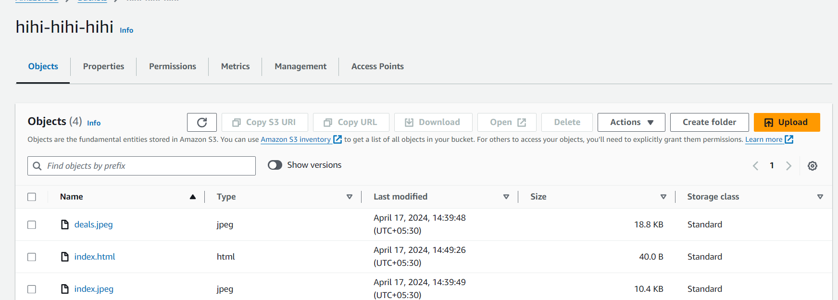

Step 2: -

* Create CloudFront distribution
* Select the s3 we created as the origin

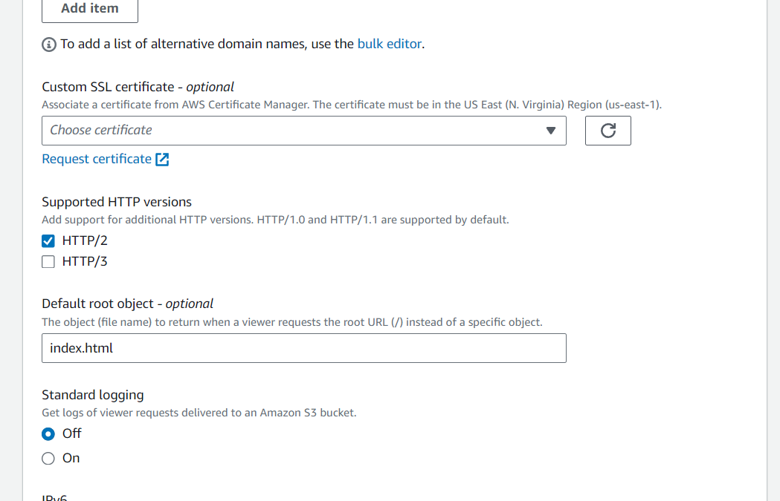

* Setting index.html as the default path so that whenever we run CloudFront distribution DNS we get landed on index page of the website we created.

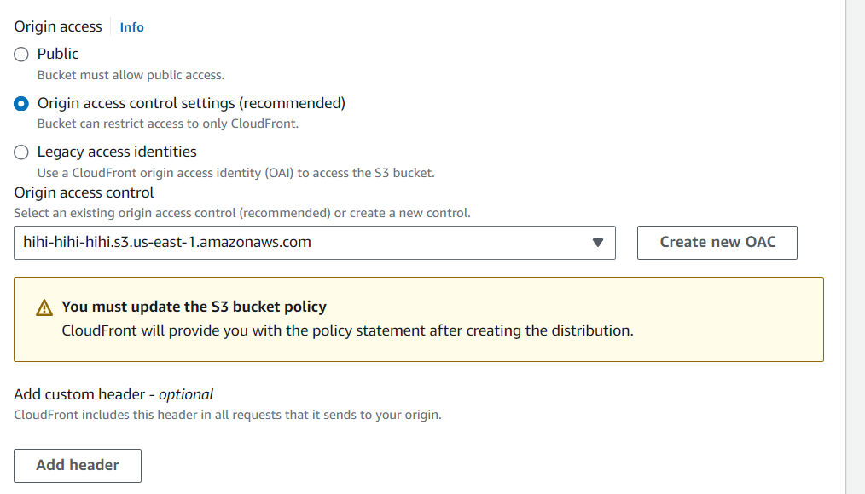

* Selection origin access as recommended as we want to keep our bucket private
* After all these settings create the distribution and wait for deployment to complete

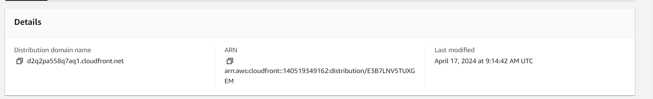

* After deployment is created copy the distribution domain name and run this DNS

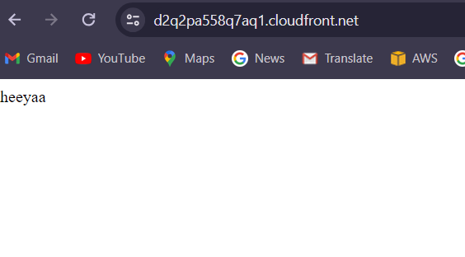

* Now we will try to access images present in the bucket by adding the path of the object(image) after the CloudFront DNS

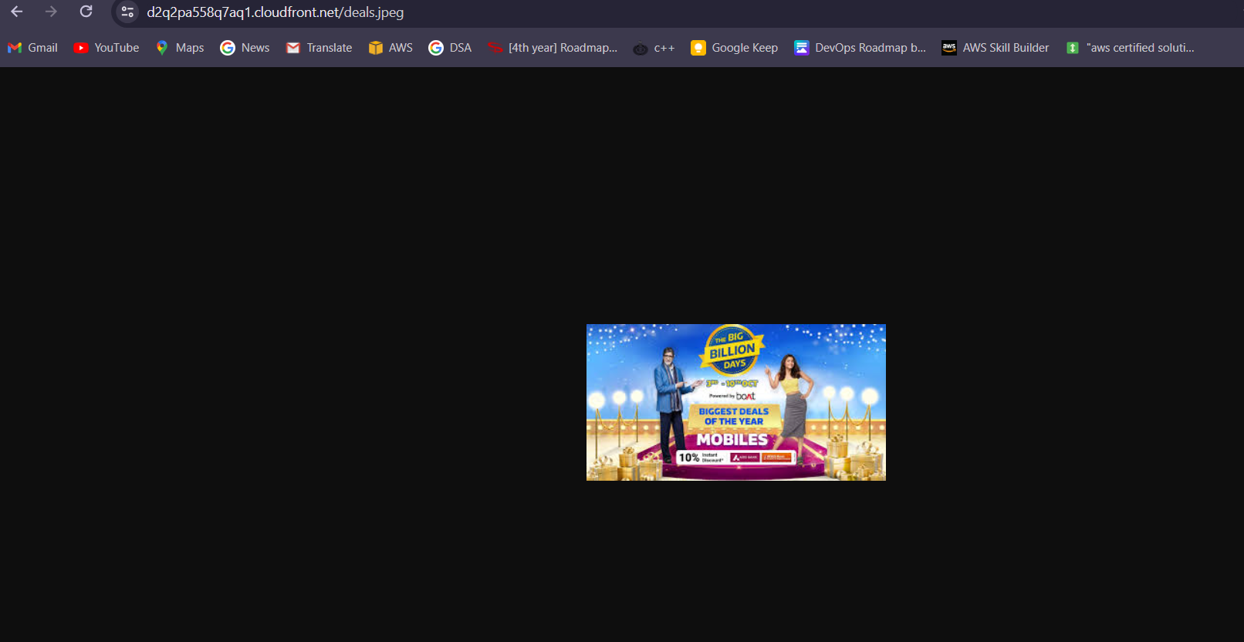

Working!!

* Now we will access in folder objects present in the bucket

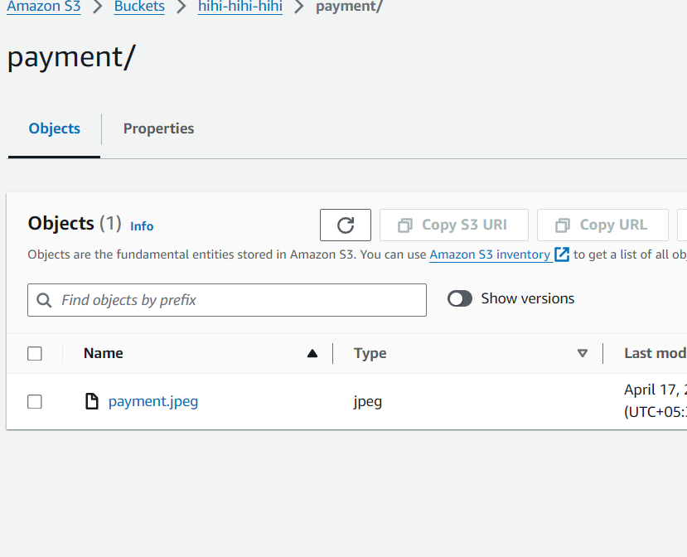

* To access this payment.jpeg file we have to add behavior in the CloudFront

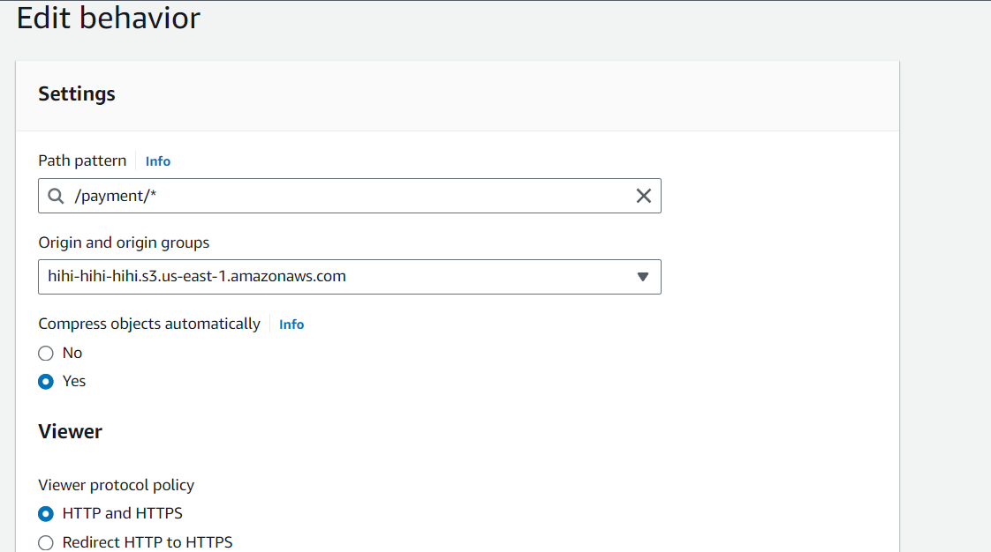

* Now we will try to access this file

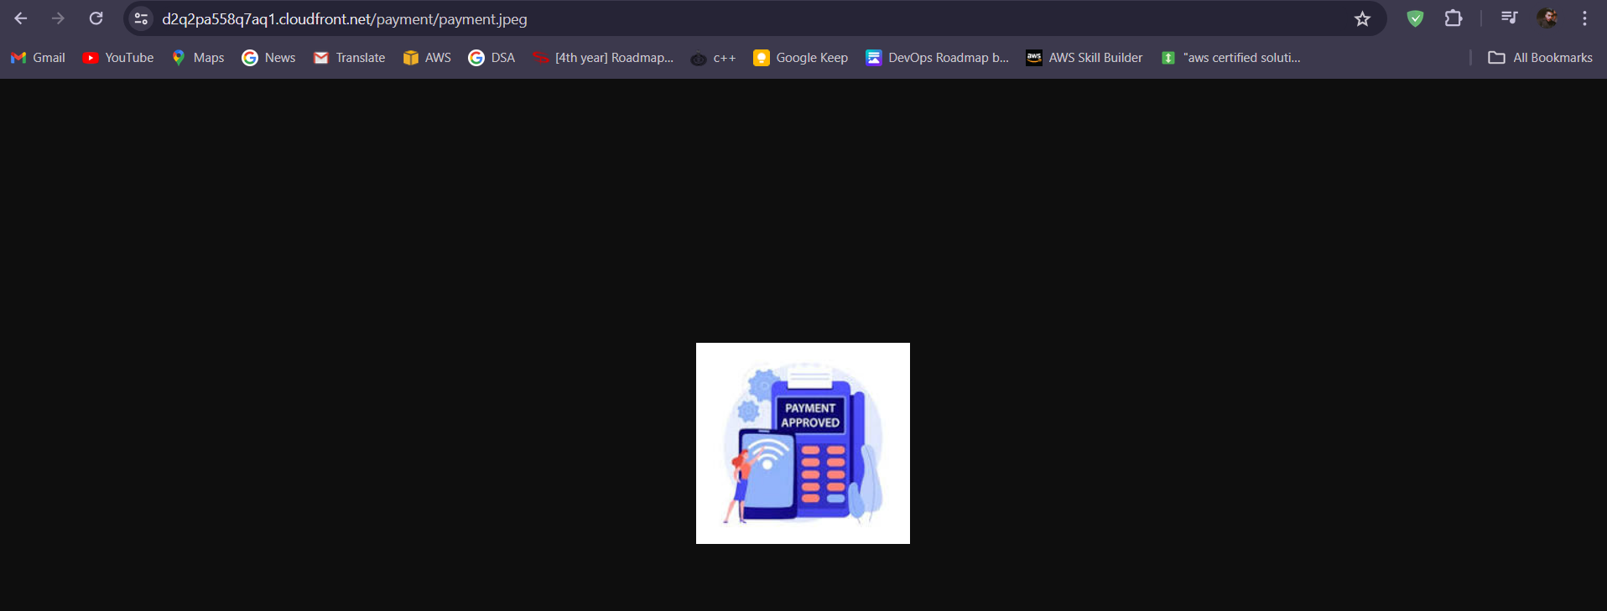

Working!!